A Real-Time (or) Field-based Research Project Report

on

**IDENTITY AUTHENTICATION FOR EXAMINATION SYSTEM**

Submitted in partial fulfillment of the requirements for the award of the degree of

**Bachelor of Technology**

in

## COMPUTER SCIENCE AND ENGINEERING

by

SOUMYA SAHU [227R1A05C1]

SADAK HANSINI [227R1A05B9]

MAIDAIM VEEKSHITHA [237R5A0510]

Under the guidance of

## Dr. D.T.V. Dharmajee Rao

Professor of CSE & Dean Academics



**DEPARTMENT OF COMPUTER SCIENCE AND ENGINEERING**

# CMR TECHNICAL CAMPUS

**UGC AUTONOMOUS**

**Accredited by NBA & NAAC with ‘A’ Grade**

**Approved by AICTE, New Delhi and JNTUH Hyderabad Kandlakoya (V), Medchal Road, Hyderabad – 501401**

**June, 2024**

## DEPARTMENT OF COMPUTER SCIENCE AND ENGINEERING



## CERTIFICATE

This is to certify that the Real-Time (or) Field-based Research Project Report entitled **“IDENTITY AUTHENTICATION FOR EXAMINATION SYSTEM”** being submitted by **SOUMYA SAHU (227R1A05C1), SADAK HANSINI (227R1A05B9), MAIDAIM VEEKSHITHA (237R5A0510)** in partial fulfillment of the requirements for the award of the degree of Bachelor of Technology in **COMPUTER SCIENCE AND ENGINEERING** to the **Jawaharlal Nehru Technological University, Hyderabad** is a record of bonafide work carried out by them under my guidance and supervision during the Academic Year 2023 – 24.

The results embodied in this thesis have not been submitted to any other University or Institute for the award of any other degree or diploma.

|  |  |
| --- | --- |
|  |  |
| **Dr. D.T.V. Dharmajee Rao** | **Dr. K. Srujan Raju** |
| **Professor of CSE & Dean Academics** | **Head of the Department** |

**Dr. A. Raji Reddy**

**Director**

# ABSTARCT

Examination System is an effective solution for mass education evaluation. The novel online examination system based on Browser/Server framework which carries out the examination and auto-grading for objective questions and operating questions has been successfully applied to the distance evaluation of basic operating skills of computer science. But most system still use username/password mode to identify the candidates. In this article, we describe a fingerprint based technology to identity authentication instead of the traditional username/password methods. A fingerprint identify/classify application and a load balance service are implemented on the examination server cooperated with the online examination system to accomplish authentication. The interfaces between the examination system and the identity authentication application can use code embed methods or SDK invoking methods to adapt different fingerprint sensors. The identity authentication works well in the Internet/intranet online examination systems.

**CONTENTS**

### Topic Page

Chapter 1 (Introduction) 1-2

* 1. Importance of Identity Authentication
  2. Objectives of Implementing Identity Authentication
  3. Key Concepts and Technologies
  4. Implementation Strategies

Chapter 2 (Literature Review) 3-5

* 1. Biometric Authentication
  2. Multi-Factor Authentication (MFA)
  3. RFID and NFC Technologies
  4. Blockchain Technology
  5. IoT Devices and Sensors
  6. Challenges and Future Directions

##### Chapter 3 (analysis and design) 6-13

* 1. Analysis
  2. Design
  3. Block Diagram

##### Chapter 4 (Implementation) 14-26

* 1. Hardware Setup
  2. Software Development
  3. Integration and Testing
  4. Code

##### Chapter 5 (Testing & Debugging) 27-30

* 1. Types of Testing
  2. Testing Approaches
  3. Debugging
  4. Result

**Chapter 6 (Conclusion) 31**

**Chapter 7 (References) 32**

# INTRODUCTION

In today's rapidly evolving digital landscape, the integration of Internet of Things (IoT) technology into educational systems, particularly for managing examinations, is revolutionizing traditional practices. The primary goal of this transformation is to ensure a seamless, efficient, and secure examination process. A fundamental aspect of this evolution is the implementation of robust identity authentication mechanisms. Identity authentication is the process of verifying that an individual is who they claim to be, which is crucial in maintaining the integrity and security of the examination system. This detailed exploration discusses the importance, objectives, and critical elements of identity authentication in IoT- based examination systems.

### Importance of Identity Authentication

The importance of identity authentication in examination systems cannot be overstated. At its core, it serves to secure the examination environment by preventing unauthorized access to exam materials and systems. This security aspect is vital as it safeguards sensitive information and ensures that only eligible individuals can participate in the examination. Beyond security, identity authentication maintains the integrity of the examination process. It ensures that the individual taking the exam is indeed the registered candidate, thereby preventing impersonation and various forms of cheating, which can undermine the credibility of the examination results. Additionally, robust authentication mechanisms provide a verifiable record of individuals who have accessed the examination system, enhancing accountability. This feature is particularly useful for audit trails and investigations, as it allows institutions to track and verify the authenticity of each participant. Furthermore, compliance with regulatory and institutional requirements is another critical aspect. Many educational and examination bodies have stringent rules regarding the security and integrity of the examination process. Implementing robust identity authentication helps meet these requirements, ensuring that the examination process adheres to legal and ethical standards.

##### Objectives of Implementing Identity Authentication

The primary objectives of integrating identity authentication into IoT-based examination systems are multifaceted. Firstly, enhancing security measures is paramount. This involves employing advanced authentication methods to safeguard against fraud and unauthorized access, thereby protecting the integrity of the examination process. Secondly, improving user experience is crucial. While maintaining high levels of security, the authentication process must be user-friendly to reduce friction and ensure a smooth experience for candidates. This balance is essential for encouraging user compliance and minimizing resistance to new technologies. Thirdly, ensuring scalability is vital. The authentication system must be capable of handling a large number of users simultaneously, which is particularly important for large-scale exams where thousands of candidates might be taking the exam at the same time. Finally, facilitating remote examinations is an important objective. With the growing trend of remote and online education, enabling secure and reliable identity verification for candidates taking exams remotely expands access to education and allows institutions to reach a broader audience.

#### Key Concepts and Technologies

The implementation of identity authentication in IoT-based examination systems relies on several key concepts and technologies. Biometric authentication is one of the most secure and reliable methods. It uses unique biological characteristics such as fingerprints, facial recognition, or iris scans to verify an individual's identity. These biometric methods are difficult to forge, providing a high level of security. Multi-Factor Authentication (MFA) is another critical technology, which combines multiple forms of verification. MFA typically involves something the user knows (like a password), something the user has (such as a smartphone or token), and something the user is (biometric data). This multi-layered approach significantly enhances security by requiring multiple proofs of identity. RFID (Radio-Frequency Identification) and NFC (Near-Field Communication) technologies are also used for quick, contactless identity verification. These technologies are particularly effective for in-person exams, providing swift and secure authentication. Blockchain technology is gaining traction in the field of identity authentication due to its decentralized and tamper-proof nature. Blockchain can provide an immutable record of authentication events, enhancing transparency and security. Finally, IoT devices and sensors play a crucial role. Various IoT devices, such as cameras, microphones, and motion sensors, can be integrated to monitor and authenticate candidates in real-time. These devices can detect unusual behavior and provide additional security layers, ensuring that the examination process is continuously monitored and secure.

#### Implementation Strategies

Effective implementation of identity authentication in IoT-based examination systems involves several strategies. Firstly, ensuring integration with existing systems is crucial. The authentication system must be compatible with current educational and examination management systems to minimize disruption and ensure a smooth transition. Secondly, providing user training and support is essential. Comprehensive training and support help users understand and adopt new authentication methods, ensuring they are comfortable and proficient with the technology. This includes clear instructions, tutorials, and troubleshooting resources. Thirdly, implementing strong data privacy and security measures is critical. Sensitive information must be protected with robust data encryption and privacy measures, complying with data protection regulations and safeguarding user data. Finally, continuous monitoring and updates are necessary to address emerging security threats and vulnerabilities. Regular updates to authentication protocols and systems ensure that they remain effective against new threats. Continuous monitoring allows for the prompt detection and response to security incidents, maintaining the integrity and security of the examination system.

# LITERATURE SURVEY

Identity authentication in IoT-based examination systems is a rapidly evolving field that leverages various technologies to ensure the integrity and security of the examination process. This literature survey reviews significant research and developments in this area, highlighting key methods, challenges, and technological advancements.

### Biometric Authentication

Biometric authentication is one of the most researched areas in identity verification for examination systems. It involves using physiological and behavioral characteristics, which are unique to each individual, to verify identity.

* + - * 1. **Fingerprint Recognition**: Fingerprint recognition is a widely used biometric technique due to its accuracy and ease of use. Research by Maltoni et al. (2009) in "Handbook of Fingerprint Recognition" demonstrates high accuracy rates and highlights the technology's reliability in large-scale applications.
        2. **Facial Recognition**: Facial recognition systems have seen significant advancements with the development of deep learning algorithms. The work of Parkhi et al. (2015) on "Deep Face Recognition" showcases how convolutional neural networks (CNNs) can achieve high accuracy in real-time applications, making them suitable for remote proctoring.
        3. **Iris Recognition**: Iris recognition is known for its high accuracy and resistance to fraud. Daugman's (2004) research on "How Iris Recognition Works" provides a comprehensive overview of the technology, demonstrating its effectiveness in secure authentication systems.
        4. **Voice Recognition**: Voice recognition systems analyze vocal characteristics for identity verification. Research by Saon et al. (2017) in "English Conversational Telephone Speech Recognition by Humans and Machines" explores the use of deep learning in improving the accuracy of voice recognition systems.

### Multi-Factor Authentication (MFA)

MFA combines multiple authentication factors to enhance security. It typically includes something the user knows (password), something the user has (token), and something the user is (biometric data).

* + - * 1. **Combined Methods**: Research by Aloul et al. (2009) in "Multi-Factor Authentication Using Mobile Phones" demonstrates the effectiveness of combining mobile-based authentication with traditional methods to enhance security in online systems.
        2. **User Experience**: Studies such as those by Das et al. (2018) in "A Study on the Usability of Multi-Factor Authentication" highlight the importance of balancing security and user convenience, showing that MFA systems must be designed to minimize user friction.

### RFID and NFC Technologies

RFID and NFC are used for quick, contactless identity verification, which is particularly useful for in-person exams.

* + - * 1. **RFID Applications**: The study by Want (2006) in "An Introduction to RFID Technology" discusses the use of RFID in various applications, including secure access control, demonstrating its potential in examination systems.
        2. **NFC in Education**: Research by Madlmayr et al. (2008) in "NFC Devices: Security and Privacy" explores the security features of NFC and its applicability in educational settings, providing insights into its use for secure identity verification in exams.

### Blockchain Technology

Blockchain technology offers a decentralized, tamper-proof method for recording and verifying identities.

* + - * 1. **Decentralized Authentication**: The work by Zyskind et al. (2015) in "Decentralizing Privacy: Using Blockchain to Protect Personal Data" illustrates how blockchain can be used to create secure and private authentication systems, reducing the risk of data breaches.
        2. **Educational Applications**: Sharples and Domingue (2016) in "The Blockchain and Kudos: A Distributed System for Educational Record, Reputation and Reward" discuss how blockchain can be applied in educational systems to maintain secure and transparent records, highlighting its potential for examination authentication.

### IoT Devices and Sensors

The integration of IoT devices and sensors plays a crucial role in real-time monitoring and authentication of candidates.

* + - * 1. **Smart Examination Rooms**: Research by Gubbi et al. (2013) in "Internet of Things (IoT): A Vision, Architectural Elements, and Future Directions" discusses the potential of IoT in creating smart environments, including examination rooms equipped with sensors and cameras for continuous monitoring.
        2. **Real-Time Authentication**: Studies such as those by S. Li et al. (2015) in "The Internet of Things: A Survey" provide insights into the use of IoT devices for real- time identity verification and monitoring, demonstrating their applicability in preventing cheating and ensuring exam integrity.

### Challenges and Future Directions

While significant progress has been made in the field of identity authentication for IoT-based examination systems, several challenges remain.

* + - * 1. **Privacy Concerns**: Ensuring the privacy of biometric and personal data is a major concern. Research by Cavoukian (2012) in "Privacy by Design" emphasizes the importance of incorporating privacy principles into the design of authentication systems.
        2. **Scalability**: The ability to scale authentication systems to handle large numbers of users simultaneously is critical. Studies such as those by Roman et al. (2011) in "On the Security and Privacy of Things" discuss the scalability issues and propose solutions for large-scale deployments.
        3. **User Acceptance**: Gaining user acceptance for new authentication methods is essential. Research by Davis (1989) in "Perceived Usefulness, Perceived Ease of Use, and User Acceptance of Information Technology" explores factors influencing user acceptance, which are crucial for the successful implementation of new technologies.
        4. **Technological Advancements**: Ongoing advancements in AI and machine learning are expected to further enhance the accuracy and reliability of authentication systems. The study by Goodfellow et al. (2016) in "Deep Learning" provides a comprehensive overview of the potential of AI in improving biometric authentication methods.

# ANALYSIS AND DESIGN

The design and implementation of an identity authentication system for IoT-based examination environments require a comprehensive understanding of both technological and user-centric aspects. This section outlines the detailed analysis and design considerations for developing a robust and efficient authentication system.

### Analysis

##### Requirement Analysis

Understanding the requirements is the first step in designing a secure and effective identity authentication system. This involves identifying the needs of stakeholders, the operational environment, and the security challenges.

##### Stakeholders:

* + - Students: Require a user-friendly, quick, and secure authentication process.
    - Educational Institutions: Need reliable and scalable systems to ensure exam integrity.
    - Administrators: Require tools for monitoring, managing, and auditing exam sessions.
    - Regulators: Demand compliance with educational and data protection standards.

##### Operational Environment:

* + - Physical Exam Centers: Need on-site authentication using biometric or RFID/NFC technology.
    - Remote Exam Locations: Require secure, internet-based authentication methods, such as biometric verification and MFA.

##### Security Challenges:

* + - Preventing impersonation and unauthorized access.
    - Ensuring data privacy and protection.
    - Managing scalability for large-scale exams.
    - Providing reliable audit trails for verification and compliance.

##### Risk Analysis

Identifying and analyzing potential risks is crucial for developing a secure authentication system.

##### Threats:

* + - Impersonation and fraudulent access attempts.
    - Data breaches and unauthorized data access.
    - Technical failures and downtime affecting authentication processes.

##### Risk Mitigation Strategies:

* + - Implementing multi-factor authentication.
    - Encrypting data both in transit and at rest.
    - Using redundant systems and regular system audits.

##### Technology Analysis

Evaluating available technologies and selecting the most suitable ones for the system.

##### Biometric Technologies:

* + - Fingerprint, facial recognition, iris scanning, and voice recognition.
    - Analysis of accuracy, user acceptance, and integration capabilities.

##### MFA (Multi-Factor Authentication):

* + - Combining passwords, tokens, and biometrics for enhanced security.

##### RFID and NFC:

* + - Quick, contactless verification methods suitable for physical exam centers.

##### Blockchain:

* + - Secure, decentralized ledger for recording authentication events.

##### IoT Devices:

* + - Cameras, microphones, and sensors for real-time monitoring and verification.

### Design

##### System Architecture

Designing a robust system architecture that integrates all components effectively.

##### Components:

* + - **User Interface (UI)**: Web and mobile interfaces for user authentication.
    - **Authentication Server**: Central server managing authentication requests and verifying identities.
    - **Biometric Devices**: Hardware for capturing biometric data.
    - **MFA Tokens**: Devices or software for generating authentication codes.
    - **IoT Devices**: Cameras, microphones, and sensors for monitoring.
    - **Blockchain Network**: Decentralized ledger for recording authentication events.

##### Architecture Design:

* + - **Client-Server Model**: Users interact with the system via a client application (web/mobile), which communicates with the central authentication server.
    - **Edge Computing**: For real-time processing of biometric data at the edge, reducing latency.
    - **Cloud Integration**: For scalable and flexible deployment of the authentication server.

##### Authentication Workflow

Defining the detailed workflow for the authentication process.

##### Initial Registration:

* + - Users (students) register their biometric data (e.g., fingerprint, facial recognition) and set up MFA during the registration process.
    - Biometric data is securely stored in an encrypted format.

##### Login Process:

* + - Users initiate the authentication process via the client application.
    - **Step 1**: Username and password verification.
    - **Step 2**: Biometric verification using fingerprint, facial recognition, or other biometric methods.
    - **Step 3**: MFA verification using a token or mobile app.

##### Continuous Monitoring:

* + - During the examination, IoT devices (cameras, microphones) continuously monitor the environment to detect any suspicious behavior or anomalies.
    - Real-time data is processed to ensure ongoing verification of the user’s identity.

##### Security Measures

Implementing robust security measures to protect the system.

##### Data Encryption:

* + - Encrypt biometric data and personal information both in transit and at rest.
    - Use advanced encryption standards (AES-256) for data security.

##### Access Control:

* + - Implement role-based access control (RBAC) to restrict access to sensitive data and functions.
    - Ensure that only authorized personnel can manage the authentication system.

##### Regular Audits:

* + - Conduct regular security audits and penetration testing to identify and mitigate vulnerabilities.
    - Maintain audit logs for all authentication events and user activities.

##### User Experience Design

Designing the system to be user-friendly and accessible.

##### Intuitive Interfaces:

* + - Develop simple and intuitive user interfaces for both the web and mobile applications.
    - Ensure that the authentication process is straightforward and easy to follow.

##### Accessibility:

* + - Ensure the system is accessible to users with disabilities, complying with accessibility standards (e.g., WCAG).

##### Feedback Mechanism:

* + - Provide clear feedback to users at each step of the authentication process.
    - Include help and support options to assist users facing difficulties.

##### Scalability and Performance

Ensuring the system can handle large-scale operations efficiently.

##### Scalability:

* + - Design the system to scale horizontally, adding more servers to handle increased load.
    - Use cloud services to dynamically scale resources based on demand.

##### Performance Optimization:

* + - Optimize biometric data processing algorithms for speed and accuracy.
    - Implement caching and load balancing to distribute the load evenly across servers.

##### Compliance and Privacy

Ensuring compliance with relevant regulations and protecting user privacy.

##### Data Protection Regulations:

* + - Comply with data protection laws such as GDPR, CCPA, and HIPAA.
    - Implement data minimization and purpose limitation principles.

##### Privacy by Design:

* + - Incorporate privacy considerations into the system design from the outset.
    - Provide users with clear information about how their data will be used and obtain their consent.

## BLOCK DIAGRAM:

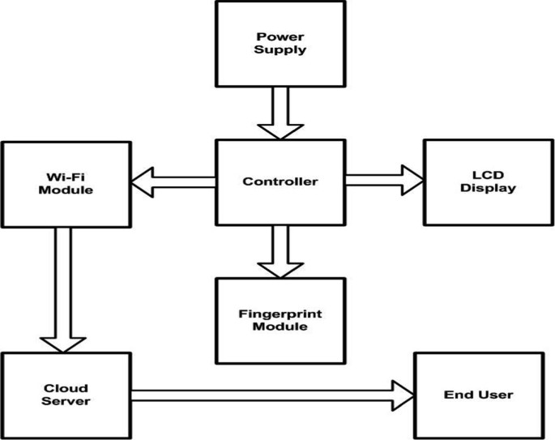

The block diagram for an identity authentication system in an IoT-based examination environment that includes a power supply controller, Wi-Fi module, LED display, fingerprint module, end user device, and cloud server highlights the interconnection and data flow between these components. Below is a detailed explanation of each component and its role in the system.

##### Block Diagram Explanation

* + - * 1. **Power Supply Management**

**Power Supply Controller**: Ensures all components receive a stable and sufficient power supply. It distributes power to the Wi-Fi module, LED display, fingerprint module, and the end user device if necessary.

##### User Interaction and Data Capture

**End User Device**: The candidate uses this device to access the examination system application.

**Fingerprint Module**: The candidate places their finger on the fingerprint scanner. The module captures the fingerprint data and sends it to the cloud server via the Wi-Fi module.

##### Wireless Communication

**Wi-Fi Module**: Facilitates the transmission of fingerprint data from the end user device and fingerprint module to the cloud server. It also receives responses from the cloud server and sends them back to the end user device and LED display.

##### Authentication and Feedback

**Cloud Server**: Upon receiving the fingerprint data, the cloud server processes and verifies it against stored biometric data. It sends the authentication result back to the end user device.

**LED Display**: Provides visual feedback to the user regarding the authentication status (e.g., "Authentication Successful," "Try Again," or "Authentication Failed").

##### Examination Access Control

**End User Device**: Based on the response from the cloud server, the examination system on the end user device grants or denies access to the examination platform.

##### Power Supply Controller

* + Ensures that all connected devices receive a stable power supply.
  + Protects against power surges and ensures continuous operation.

##### Wi-Fi Module

* + Connects the system to the internet, enabling communication between the end user device, fingerprint module, and cloud server.
  + Sends captured fingerprint data to the cloud server for processing.
  + Receives authentication results from the cloud server.

##### LED Display

* + Provides immediate visual feedback to the user.
  + Displays messages such as "Please place your finger," "Processing...," "Authentication Successful," or "Authentication Failed."

##### Fingerprint Module

* + Captures the candidate’s fingerprint data.
  + Sends the data to the cloud server through the Wi-Fi module for verification.

##### End User Device

* + Initiates the authentication process by prompting the user to use the fingerprint module.
  + Communicates with the Wi-Fi module to send and receive data.
  + Displays the authentication result and grants or denies access to the examination system based on the server’s response.

##### Cloud Server

* + Receives fingerprint data from the end user device.
  + Verifies the fingerprint data against stored biometric information.
  + Sends the authentication result back to the end user device and updates the LED display.

##### Data Flow Process

1. **Initiation**: The user starts the authentication process on the end user device.
2. **Fingerprint Capture**: The user places their finger on the fingerprint module, which captures the fingerprint data.
3. **Data Transmission**: The fingerprint data is sent to the cloud server via the Wi-Fi module.
4. **Verification**: The cloud server verifies the fingerprint data against stored records.
5. **Result Communication**: The cloud server sends the authentication result back to the end user device through the Wi-Fi module.
6. **Feedback Display**: The LED display shows the authentication status to the user.
7. **Access Control**: Based on the authentication result, the end user device either grants or denies access to the examination system.

The block diagram for an identity authentication system in an IoT-based examination environment integrates various components to ensure secure, efficient, and user-friendly authentication. The system combines hardware (fingerprint module, LED display, power supply controller) and communication technology (Wi-Fi module, cloud server) to provide a seamless experience. The power supply controller ensures uninterrupted operation, the Wi-Fi module facilitates data transmission, the fingerprint module captures biometric data, and the cloud server processes and verifies this data, ultimately determining access to the examination system. This integrated approach ensures a robust and reliable identity authentication process, enhancing the security and integrity of the examination system.

# 3.3 IOT KIT

Creating a robust identity authentication system for an examination system is crucial to ensure the integrity and security of the examination process. Here’s a detailed kit explanation for setting up such a system:

1. Biometric Devices

* **Fingerprint Scanner**: Captures and verifies fingerprint data.
* **Facial Recognition Camera**: High-resolution camera with facial recognition capabilities.

1. RFID/NFC Reader

* **RFID/NFC Reader**: Scans RFID/NFC tags embedded in student ID cards for identification purposes.

1. Smart Card Reader

* **Smart Card Reader**: Reads smart cards for additional authentication.

1. Cameras

* **Webcam**: For real-time photo capture and proctoring.
* **Surveillance Cameras**: For monitoring the examination environment.

1. Sensors

* **Presence Sensors**: Detect the presence of candidates in the examination room.
* **Environmental Sensors**: Monitor conditions like temperature and humidity to ensure a comfortable examination environment.

1. Microcontroller/Processor

* **Raspberry Pi/Arduino**: Acts as the central hub for connecting and managing all IoT devices.

1. Communication Modules

* **Wi-Fi Module**: Ensures devices are connected to the network.
* **Bluetooth Module**: For short-range communication between devices.

1. Displays

* **LCD/LED Display**: Shows status messages and prompts for candidates.

### Software Components

1. Authentication Software

* **Biometric Matching Algorithms**: Software for matching fingerprint and facial recognition data.
* **RFID/NFC Reader Software**: Interface for reading and validating RFID/NFC tags.

1. Database

* **User Data Storage**: Secure database for storing user information and biometric data.

1. User Interface

* **Web/Mobile Application**: For user registration, login, and real-time monitoring.

1. Proctoring Software

* **AI-Based Proctoring**: Monitors candidate behavior during the exam using AI algorithms.
* **Manual Proctoring Interface**: Allows human proctors to oversee the examination process.

# IMPLEMENTATION

The implementation of an identity authentication system for an IoT-based examination environment is a multifaceted project requiring careful planning and execution. This implementation guide covers various stages including hardware setup, software development, integration, testing, and deployment. Each stage is elaborated in detail to ensure a comprehensive understanding of the process.

### Hardware Setup

The hardware setup is the foundational phase of the implementation. It involves the installation and configuration of essential components such as the power supply controller, Wi-Fi module, fingerprint module, LED display, and the end user devices. Each component plays a crucial role in the system, and their proper setup ensures reliable performance.

1. **Power Supply Controller** The power supply controller is pivotal for providing a stable and continuous power supply to all the hardware components. This controller typically includes power supply units, voltage regulators, and capacitors to manage and stabilize the voltage levels. Proper setup involves connecting the power supply to each component, ensuring that voltage and current requirements are meticulously met. This not only prevents

hardware failures but also guarantees the smooth operation of the entire system during the examination process.

1. **Wi-Fi Module** The Wi-Fi module, such as the ESP8266 or ESP32, is responsible for enabling wireless communication within the system. It connects the fingerprint module, end user devices, and the cloud server, facilitating the transmission of data. The setup process includes configuring the Wi-Fi module to connect to a secure network, ensuring reliable and fast communication. Proper security protocols, such as WPA2, should be implemented to protect the data transmitted over the network.
2. **Fingerprint Module** The fingerprint module captures and processes the biometric data of the users. Modules such as the R305 or GT-521F52 are commonly used for this purpose. The setup involves connecting the fingerprint module to the end user device and ensuring it can capture and transmit high-quality biometric data. Calibration and initial testing are essential to verify that the module accurately captures fingerprint details under various conditions.
3. **LED Display** The LED display provides real-time feedback to the users during the authentication process. It displays messages like "Please place your finger," "Authentication Successful," or "Authentication Failed." Setting up the LED display involves integrating it with the end user device and the Wi-Fi module so it can receive and display status messages sent from the cloud server.
4. **End User Device** The end user device, which can be a laptop, tablet, or smartphone, serves as the interface for the candidates. It initiates the authentication process and interacts with other hardware components. The setup includes installing the necessary application software that communicates with the fingerprint module and the Wi-Fi module, and providing a user-friendly interface for the candidates.

### Software Development

The software development phase is critical for creating the applications and services that manage the authentication process. This phase includes developing the client application, the server-side software, and the integration of biometric and security protocols.

1. **Client Application** The client application runs on the end user devices and interfaces with the fingerprint module and the Wi-Fi module. This application must be intuitive and user- friendly, guiding candidates through the authentication process. It includes modules for capturing biometric data, sending data to the cloud server, and displaying feedback from the LED display. Technologies such as React Native or Flutter can be used to develop cross- platform applications.
2. **Server-Side Software** The server-side software, hosted on the cloud server, manages the authentication requests. This includes processing biometric data, verifying it against stored templates, and communicating the results back to the client application and LED display. The server software should be developed using robust frameworks such as Node.js or Django, ensuring scalability and security. Integration with a biometric database and

implementing strong encryption methods for data transmission and storage are critical components of this phase.

1. **Security and Privacy** Implementing multi-factor authentication (MFA) and robust encryption protocols is essential for securing the system. The client application should incorporate MFA mechanisms, such as OTPs generated by mobile apps or hardware tokens. Data transmitted between the client application and the server must be encrypted using SSL/TLS protocols. Additionally, biometric data should be encrypted both in transit and at rest, using advanced encryption standards like AES-256.

### Integration and Testing

Integration and testing are vital for ensuring that all components work seamlessly together. This phase involves comprehensive testing of hardware and software components, individually and as a complete system.

1. **Integration Testing** Integration testing ensures that the fingerprint module, Wi-Fi module, LED display, end user devices, and the cloud server communicate correctly and efficiently. This involves testing the data flow from fingerprint capture to authentication result feedback. Any issues in communication protocols, data handling, or synchronization must be identified and resolved.
2. **Functional Testing** Functional testing focuses on verifying that each function of the authentication system works as intended. This includes user registration, biometric data capture, authentication processing, and result display. Test cases should cover all possible scenarios, including edge cases, to ensure robust performance.
3. **Security Testing** Security testing is critical to identify vulnerabilities in the system. This involves testing the encryption protocols, MFA mechanisms, and overall data protection strategies. Penetration testing should be conducted to simulate potential attacks and ensure that the system is resilient against threats such as data breaches and unauthorized access.
4. **User Acceptance Testing (UAT)** UAT involves real users, such as students and exam administrators, testing the system under real-world conditions. Feedback from these users is crucial for identifying usability issues and making necessary adjustments to the user interface and overall user experience.

### Deployment and Maintenance

The final phase involves deploying the system and ensuring its ongoing maintenance and support.

1. **Deployment** Deployment includes setting up the cloud server environment, installing the client applications on end user devices, and configuring all hardware components. The system should be deployed in a controlled environment initially, followed by a gradual rollout to ensure any unforeseen issues can be addressed promptly.
2. **Training and Support** Training sessions for users and administrators are essential for smooth operation. Users need to understand how to use the fingerprint module and client application, while administrators should be trained on managing the server-side software and handling any technical issues that arise.
3. **Monitoring and Maintenance** Continuous monitoring of the system is necessary to ensure its performance and security. Automated monitoring tools can help track system health, detect anomalies, and alert administrators to potential issues. Regular maintenance, including software updates and security patches, is crucial for keeping the system secure and up-to-date.
4. **Scalability and Future Enhancements** The system should be designed to scale as the number of users increases. Future enhancements may include integrating additional biometric modalities, improving the user interface, and enhancing security features. Feedback from users and advancements in technology should guide ongoing development efforts.

## 4.4 CODE:

#include <SoftwareSerial.h> SoftwareSerial mySerial(8,9); #include <LiquidCrystal.h> LiquidCrystal lcd(6, 7, 5, 4, 3, 2); char res[130];

unsigned char

enroll[12]={0xEF,0X01,0XFF,0XFF,0XFF,0XFF,0X01,0X00,0X03,0X01,0X00,0X05};

// ok

unsigned char

generate_ch[13]={0xEF,0X01,0XFF,0XFF,0XFF,0XFF,0X01,0X00,0X04,0x02,0X01,0X

00,0X08}; //ok

unsigned char

generate_ch1[13]={0xEF,0X01,0XFF,0XFF,0XFF,0XFF,0X01,0X00,0X04,0x02,0X02,0 X00,0X09}; //ok

unsigned char un_cmd[12]={0xef,0x01,0xff,0xff,0xff,0xff, 0x01,0x00,0x03,0x05,0x00,0x09 };

unsigned char

store[12]={0xEF,0X01,0XFF,0XFF,0XFF,0XFF,0X01,0X00,0X06,0X06,0X02,0x00};

//ok

unsigned char

identify[17]={0xef,0x01,0xff,0xff,0xff,0xff,0x01,0x00,0x08,0x1b,0x01,0x00,0x00,0x01,0 x01,0x00,0x27};

int party1_count=0,party2_count=0,total_count=0; int sts0=0,sts1=0,sts2=0,sts3=0;

char rcv;

char pastnumber[11]; void okcheck()

{

unsigned char rcr; do{

rcr = Serial.read();

}while(rcr != 'K');

}

void serialFlush(){ while(Serial.available() > 0) { char t = Serial.read();

}

}

int fpenroll(char); int fpsearch();

int err =0;

int enrol_sw = 10;

int identi_sw = 11; int buzzer = 13; int relay = A5; int idk = 0,eid=0; void beep()

{

digitalWrite(buzzer, LOW);delay(3000);digitalWrite(buzzer, HIGH);

}

void setup()

{

pinMode(enrol_sw, INPUT); pinMode(identi_sw, INPUT); pinMode(buzzer, OUTPUT); pinMode(relay, OUTPUT); digitalWrite(enrol_sw, HIGH); digitalWrite(identi_sw, HIGH); digitalWrite(buzzer, HIGH); digitalWrite(relay, LOW); Serial.begin(9600); mySerial.begin(57600); lcd.begin(16,2);

lcd.clear();lcd.print("Identity Authentictaion")

delay(4000); //delay(000);

}

void loop()

{ mn:

if(digitalRead(enrol_sw) == LOW)

{

lcd.clear();lcd.setCursor(0, 0);lcd.print("ENROLLING.."); if(fpenroll(eid) == -1)

{

//Serial.print("Enroll failed:");Serial.print(err);Serial.println(""); err=0;

lcd.clear();lcd.setCursor(0, 0);lcd.print("ENROLL FAILED");

}

else

//if(eid >= 0 && eid <= 9)

{

lcd.clear();lcd.setCursor(0, 0);lcd.print("ENROLLED:");lcd.print((int)eid);

//Serial.print("Enroll Success to id:");Serial.print((int)eid);Serial.println(""); eid++;

}

delay(2000);

// lcd.clear();lcd.setCursor(0, 0);lcd.print("SELECT OPTION");

}

if(digitalRead(identi_sw) == LOW)

{

lcd.clear();lcd.setCursor(0, 0);lcd.print("Identifing..");

idk = fpsearch(); if(err == 1)

{err=0;

lcd.clear();lcd.print("Not Found...");

digitalWrite(buzzer, LOW);delay(2000);delay(2000);digitalWrite(buzzer, HIGH);

}

if(idk >= 0 && idk <= 9)

{

lcd.clear();lcd.print("Correct Match"); lcd.setCursor(0,1);lcd.print("Accessed"); delay(3000); //delay(000);

}

}//identify delay(500);

}

int ct=0;

char dummy=0x0f; int fpenroll(char id)

{

serialFlush();

//enroll buffer send 12 byte for(int i =0;i<13;i++)

mySerial.write(generate_ch[i]);

res[9] = 1;

delay(1000);//wait some time to get replay from r305 while(mySerial.available()){res[ct] = mySerial.read();ct++;}ct=0; if(res[9] == 0){}

else{err=2;return -1;}

//enroll buffer send 12 bytes for(int i =0;i<12;i++)

mySerial.write(enroll[i]); res[9] = 1;//

delay(1000);//wait some time to get replay from r305 while(mySerial.available()){res[ct] = mySerial.read();ct++;}ct=0; if(res[9] == 0){}

else{err=3;return -1;}

//generate ch1 buffer for(int i =0;i<13;i++)

mySerial.write(generate_ch1[i]); res[9] = 1;

delay(1000);//wait some time to get replay from r305 while(mySerial.available()){res[ct] = mySerial.read();ct++;}ct=0; if(res[9] == 0){}

else{err=4;return -1;}

//uncmd buffer send 12 bytes for(int i =0;i<12;i++)

mySerial.write(un_cmd[i]);

res[9] = 1;//

delay(1000);//wait some time to get replay from r305 while(mySerial.available()){res[ct] = mySerial.read();ct++;}ct=0; if(res[9] == 0){}

else{err=5;return -1;}

//store buffer send 12 bytes for(int i =0;i<12;i++)

mySerial.write(store[i]); dummy = 0x0f+id; mySerial.write((uint8_t)id); mySerial.write((uint8_t)0x00); mySerial.write((uint8_t)dummy); res[9] = 1;//

delay(1000);//wait some time to get replay from r305 while(mySerial.available()){res[ct] = mySerial.read();ct++;}ct=0; if(res[9] == 0){return id;}

else{err=6;return -1;}

}

int fpsearch()

{

ct=0; serialFlush();

//enroll buffer send 12 bytes for(int i =0;i<13;i++)

mySerial.write(generate_ch[i]); res[9] = 1;

delay(1000);//wait some time to get replay from r305 while(mySerial.available()){res[ct] = mySerial.read();ct++;}ct=0; if(res[9] == 0){}

else{err=2;return -1;}

//enroll buffer send 12 bytes for(int i =0;i<17;i++)

mySerial.write(identify[i]); res[9] = 1;//

delay(1000);//wait some time to get replay from r305 while(mySerial.available()){res[ct] = mySerial.read();ct++;}ct=0; if(res[9] == 0){return (int)res[11];}

else{err=1;return -1;}

}

int readSerial(char result[])

{

int i = 0; while (1)

{

while (Serial.available() > 0)

{

char inChar = Serial.read(); if (inChar == '\n')

{

result[i] = '\0'; Serial.flush(); return 0;

}

if (inChar != '\r')

{

result[i] = inChar; i++;

}

}

}

}

void converts(unsigned int value)

{

unsigned int a,b,c,d,e,f,g,h a=value/10000; b=value%10000; c=b/1000;

d=b%1000;

e=d/100; f=d%100;

g=f/10; h=f%10;

a=a|0x30; c=c|0x30; e=e|0x30; g=g|0x30; h=h|0x30; Serial.write(a); Serial.write(c); Serial.write(e); Serial.write(g); Serial.write(h);

}

void convertl(unsigned int value)

{

unsigned int a,b,c,d,e,f,g,h; a=value/10000; b=value%10000; c=b/1000;

d=b%1000;

e=d/100; f=d%100;

g=f/10; h=f%10;

a=a|0x30; c=c|0x30;

e=e|0x30; g=g|0x30; h=h|0x30; lcd.write(a);

lcd.write(c);

lcd.write(h);

}

# TESTING AND DEBUGGING

### Types of Testing

##### Unit Testing:

* + - **Purpose:** Test individual components (e.g., fingerprint module, Wi-Fi module, client application) in isolation.
    - **Methods:** Use testing frameworks (e.g., JUnit for Java, Jest for JavaScript) to verify that each unit behaves as expected.
    - **Focus:** Validate functionality, inputs, outputs, and error handling of each unit.

##### Integration Testing:

* + - **Purpose:** Test how components work together as a system.
    - **Methods:** Simulate interactions between hardware (e.g., fingerprint module, LED display) and software components (e.g., client application, server-side software).
    - **Focus:** Verify data flow, communication protocols, and compatibility between different modules.

##### System Testing:

* + - **Purpose:** Test the entire system end-to-end.
    - **Methods:** Conduct comprehensive tests covering all functionalities, use cases, and scenarios that users may encounter.
    - **Focus:** Validate system behavior, performance under load, security features, and overall user experience.

##### Security Testing:

* + - **Purpose:** Identify and address security vulnerabilities.
    - **Methods:** Perform penetration testing, vulnerability assessments, and security audits.
    - **Focus:** Ensure data protection, encryption, authentication mechanisms (e.g., MFA), and resistance to attacks (e.g., spoofing, tampering).

### Testing Approaches

##### Functional Testing:

* + - **Scenario Testing:** Test typical user scenarios (e.g., authentication process from start to finish).
    - **Edge Case Testing:** Test unusual or boundary scenarios (e.g., extreme biometric conditions, network interruptions).
    - **Error Handling Testing:** Validate how the system responds to unexpected inputs or failures.

##### Performance Testing:

* + - **Load Testing:** Assess system performance under expected and peak loads.
    - **Stress Testing:** Determine system behavior at or beyond capacity limits.
    - **Latency Testing:** Measure response times for critical operations (e.g., fingerprint capture, authentication).

##### Usability Testing:

* + - **User Acceptance Testing (UAT):** Gather feedback from real users (e.g., students, administrators) on usability and functionality.
    - **Accessibility Testing:** Ensure the system is accessible to all users, including those with disabilities.

### Debugging

##### Logging and Monitoring:

* + - **Purpose:** Capture and analyze system behavior during testing.
    - **Methods:** Implement logging frameworks (e.g., Log4j, Winston) to record events, errors, and performance metrics.
    - **Analysis:** Review logs to identify issues, trace execution flow, and diagnose root causes of errors.

##### Debugging Tools:

* + - **IDE Debuggers:** Use integrated development environment (IDE) debuggers (e.g., Visual Studio Code, IntelliJ IDEA) for step-by-step execution and variable inspection.
    - **Remote Debugging:** Debug applications running on remote devices or servers using tools like Chrome DevTools or remote debuggers provided by hardware manufacturers.

##### Code Reviews:

* + - **Purpose:** Identify potential issues through peer review.
    - **Methods:** Conduct thorough code reviews to ensure adherence to coding standards, identify logic errors, and improve code quality.
    - **Feedback:** Provide constructive feedback to developers and address issues early in the development process.
  1. **RESUL**

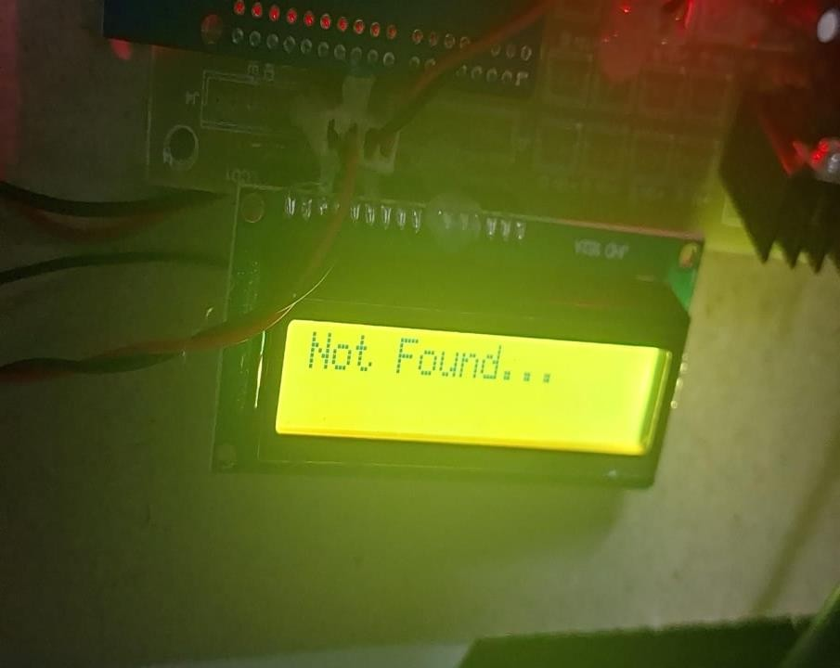

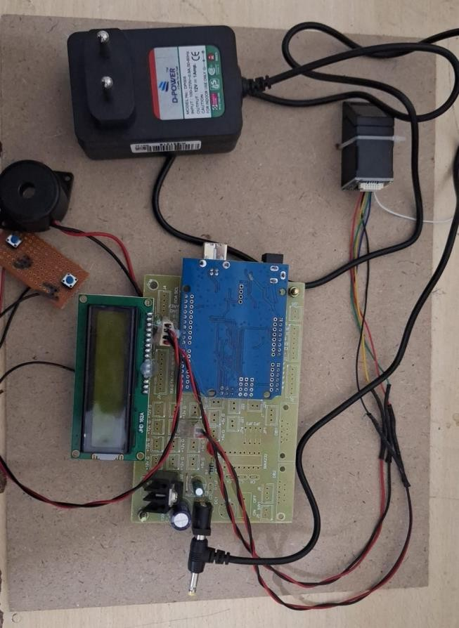

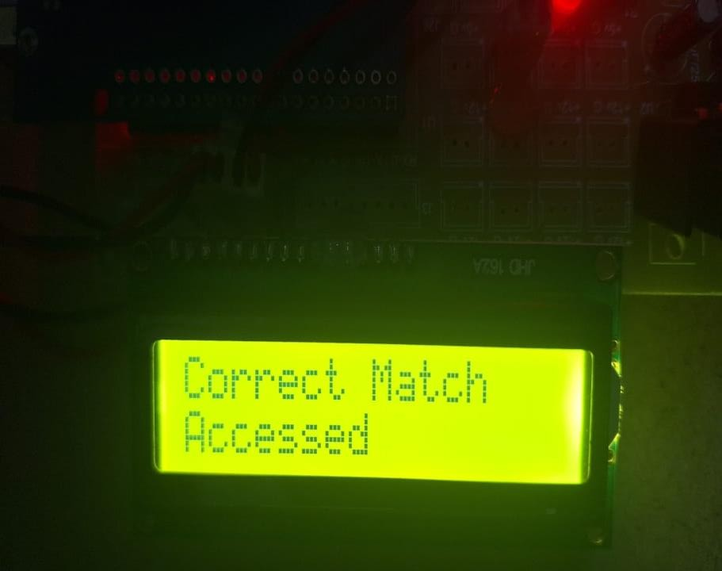

# CONCLUSION

In conclusion, the implementation of an identity authentication system for an IoT-based examination environment involves a meticulous and comprehensive approach spanning hardware setup, software development, testing, and debugging. Each phase is critical to ensuring the system's functionality, security, and reliability in authenticating candidates during examinations.

The hardware setup phase establishes the foundation with components like the power supply controller, Wi-Fi module, fingerprint module, LED display, and end user devices. This setup ensures that each component receives stable power and can communicate effectively within the system. The integration of these hardware components is essential for seamless operation during the authentication process.

Software development encompasses the creation of client applications, server-side software, and the implementation of security protocols. The client application, running on end user devices, facilitates biometric data capture and communicates with the server-side software via the Wi-Fi module. This software, hosted on a cloud server, manages authentication requests, verifies biometric data against stored records, and ensures secure data transmission through encryption protocols.

Testing is a rigorous process that validates the system's functionality, performance, and security. Unit testing verifies individual components, integration testing ensures compatibility and communication between components, and system testing evaluates the system as a whole. Security testing is crucial to identifying and mitigating vulnerabilities, ensuring that sensitive biometric data is protected from unauthorized access or breaches.

Debugging plays a pivotal role in identifying and resolving issues that arise during testing. Through logging, monitoring, and the use of debugging tools, developers can trace and diagnose errors, ensuring the system operates reliably under varying conditions. Code reviews further enhance code quality and identify potential improvements or optimizations.

Throughout the project, user feedback and usability testing, such as user acceptance testing (UAT), provide valuable insights into the system's usability and effectiveness in real-world scenarios. Adjustments based on user feedback ensure that the system meets the expectations and requirements of candidates and administrators alike.

In conclusion, the successful implementation of an identity authentication system for an examination environment hinges on thorough planning, meticulous execution, and continuous refinement through testing and debugging. By adhering to best practices in hardware setup, software development, testing methodologies, and user feedback integration, the system can effectively ensure the security, integrity, and reliability necessary for conducting fair and secure examinations in today's digital age.

# REFERENCES

For a comprehensive project on identity authentication for examinations, consider referencing key scholarly articles such as [A Survey on Biometric Authentication](https://www.sciencedirect.com/science/article/pii/S0031320312002585) [Methods](https://www.sciencedirect.com/science/article/pii/S0031320312002585) and [Biometric Authentication in Online Examinations: A Review,](https://ieeexplore.ieee.org/document/7426764) which provide detailed insights into biometric systems used in educational settings. Essential books like [Biometrics: Identity Verification in a Networked World](https://www.amazon.com/Biometrics-Identity-Verification-Networked-World/dp/0471099457) by Nanavati et al. and [Handbook of Fingerprint Recognition](https://link.springer.com/book/10.1007/978-1-4757-2450-4) by Maltoni et al. offer foundational knowledge on biometric technologies. Industry resources, including the white paper Biometric Solutions for Secure Examination Environments and the report The Role of Digital Identity Verification in Education, present practical applications and market trends. Standards like ISO/IEC 19794-1:2011 on biometric data formats and [NIST Special Publication 800-63B](https://pages.nist.gov/800-63-3/sp800-63b.html) on digital identity guidelines are crucial for understanding technical and regulatory frameworks. Additionally, online articles such as The Future of Student Authentication: Emerging Technologies and Trends and blogs on Implementing Secure Online Exams: Best Practices provide current perspectives and practical advice. These sources collectively offer a robust foundation for exploring identity authentication in examination contexts.